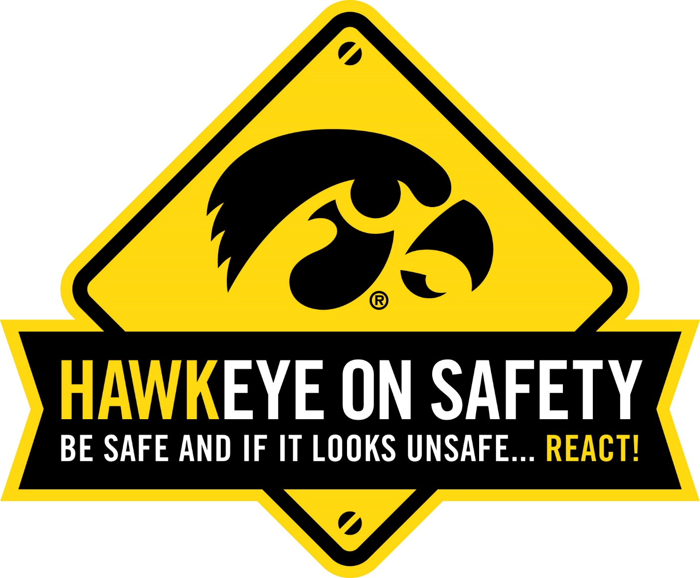

3rd Annual Excellence in Safety Award
Sponsored by: Hawkeye on Safety Planning Committee
Presented at the 5th Annual Hawkeye on Safety Conference
Thursday, October 11th, 2018

Successful workplace safety is the commitment and willingness of every individual to pursue a safe, healthful and environmentally sound work place. The Hawkeye on Safety conference committee annually recognizes an individual who is dedicated to making their workplace safer. Winners will receive a plaque and recognition at the 5th Annual Hawkeye on Safety Conference in Coralville, Iowa. Additionally, they will be given an opportunity at the conference to present the safety information that was given to the committee as application for the award.

Criteria:
Nominees must satisfy at least 1 or more of the following 5 criteria:
- Implementing a safety program in their workplace.
- Taking an active role and being a strong advocate for safety and health.
- Demonstrating significant improvement over previous conditions
- Consistently maintaining a good safety program over a number of years.
- Making an extra effort to improve or correct a specific aspect of safety within the workplace.

Nominee Name: _________________________________________________________

Nominee’s Employer: _____________________________________________________

Position/Title: ___________________________________________________________

Years of Service to Employer: _______________________________________________

Describe why nominee deserves this award. Include examples and specifics. You are welcome to submit documents and/or photos to support your nomination, if desired or applicable.

List references or contacts that may be useful if the committee needs additional information:

Additional information may be requested from the submitter as the committee narrows their selection of qualified candidates.

Submitter’s Name and Title: _____________________________________________________

Submitter’s Employer: __________________________________________________________

Does Submitter supervise Nominee? Y or N

Submitter’s Contact Information:
Phone: _______________________________________
Email: ________________________________________

Paper applications should be submitted to:
Tammi Goerdt
Director of Continuing Education and Outreach
The Heartland Center for Occupational Health & Safety
University of Iowa, College of Public Health
145 N. Riverside Drive
100 CPHB, S310
Iowa City, Iowa 52242
or email to: tammi-goerdt@uiowa.edu

